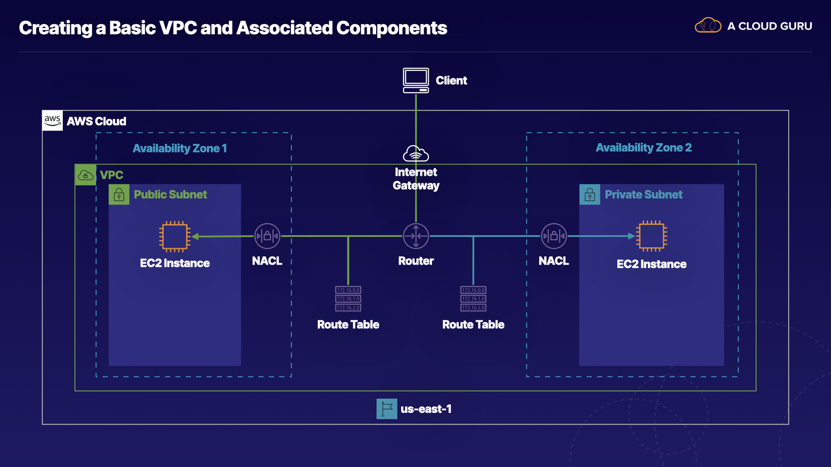

Creating a Basic VPC and Associated Components

Introduction
In this hands-on lab, we will create a VPC with an internet gateway, as well as create subnets across multiple Availability Zones.

Solution
Log in to the live AWS environment using the credentials provided. Make sure you're in the N. Virginia (us-east-1) region throughout the lab.

Create a VPC
- Navigate to the VPC dashboard.
- Click Your VPCs in the left-hand menu.
- Click Create VPC, and set the following values:
  - Name tag: VPC1
  - IPv4 CIDR block: 172.16.0.0/16
- Leave the IPv6 CIDR block and Tenancy fields as their default values.
- Click Create.

Create an Internet Gateway, and Connect It to the VPC
- Click Internet Gateways in the left-hand menu.
- Click Create internet gateway.
- Give it a Name tag of "IGW".
- Click Create internet gateway.
- Once it's created, click Actions > Attach to VPC.
- In the Available VPCs dropdown, select our VPC1.
- Click Attach internet gateway.

Create a Public and Private Subnet in Different Availability Zones

Create Public Subnet
- Click Subnets in the left-hand menu.
- Click Create subnet, and set the following values:
  - Name tag: Public1
  - VPC: VPC1
  - Availability Zone: us-east-1a
  - IPv4 CIDR block: 172.16.1.0/24
- Click Create.

Create Private Subnet
- Click Create subnet, and set the following values:
  - Name tag: Private1
  - VPC: VPC1
  - Availability Zone: us-east-1b
  - IPv4 CIDR block: 172.16.2.0/24
- Click Create.

Create Two Route Tables, and Associate Them with the Correct Subnet

Create and Configure Public Route Table
- Click Route Tables in the left-hand menu.
- Click Create route table, and set the following values:
  - Name tag: PublicRT
  - VPC: VPC1
- Click Create.
- With PublicRT selected, click the Routes tab on the page.
- Click Edit routes.
- Click Add route, and set the following values:
  - Destination: 0.0.0.0/0
  - Target: Internet Gateway > IGW
- Click Save routes.
- Click the Subnet Associations tab.
- Click Edit subnet associations.
- Select our Public1 subnet.
- Click Save.

Create and Configure Private Route Table
- Click Create route table, and set the following values:
  - Name tag: PrivateRT
  - VPC: VPC1
- Click Create.
- With PrivateRT selected, click the Subnet Associations tab.
- Click Edit subnet associations.
- Select our Private1 subnet.
- Click Save.

Create Two Network Access Control Lists (NACLs), and Associate Each with the Proper Subnet

Create and Configure Public NACL
- Click Network ACLs in the left-hand menu.
- Click Create network ACL, and set the following values:
  - Name tag: Public_NACL
  - VPC: VPC1
- Click Create.
- With Public_NACL selected, click the Inbound Rules tab below.
- Click Edit inbound rules.
- Click Add Rule, and set the following values:
  - Rule #: 100
  - Type: HTTP (80)
  - Port Range: 80
  - Source: 0.0.0.0/0
  - Allow / Deny: ALLOW
- Click Add Rule, and set the following values:
  - Rule #: 110
  - Type: SSH (22)
  - Port Range: 22
  - Source: 0.0.0.0/0
  - Allow / Deny: ALLOW
- Click Save.
- Click the Outbound Rules tab.
- Click Edit outbound rules.
- Click Add Rule, and set the following values:
  - Rule #: 100
  - Type: Custom TCP Rule
  - Port Range: 1024-65535
  - Destination: 0.0.0.0/0
  - Allow / Deny: ALLOW
- Click Save.
- Click the Subnet associations tab.
- Click Edit subnet associations.
- Select the Public1 subnet, and click Edit.

Create and Configure Private NACL
- Click Create network ACL, and set the following values:
  - Name tag: Private_NACL
  - VPC: VPC1
- Click Create.
- With Private_NACL selected, click the Inbound Rules tab below.
- Click Edit inbound rules.
- Click Add Rule, and set the following values:
  - Rule #: 100
  - Type: SSH (22)
  - Port Range: 22
  - Source: 172.16.1.0/24
  - Allow / Deny: ALLOW
- Click Save.
- Click the Outbound Rules tab.
- Click Edit outbound rules.
- Click Add Rule, and set the following values:
  - Rule #: 100
  - Type: Custom TCP Rule
  - Port Range: 1024-65535
  - Destination: 0.0.0.0/0
  - Allow / Deny: ALLOW
- Click Save.
- Click the Subnet associations tab.
- Click Edit subnet associations.
- Select the Private1 subnet, and click Edit.

Conclusion
Congratulations on completing this hands-on lab!

